 |  |  |  |  |  |  |  |  |  | Order Date:
 |  |  |  |  |  |  |  |  |  | Submit Forms/Make Checks Payable to:
Good Sports
1027 17th Street
Bedford, IN 47421
812.275.5229
goodsports2@comcast.net
http://www.shopgoodsports.com/

BNL Baseball SPIRIT WEAR FUNDRAISER order form

This is a fundraiser. A portion (up to 30%) of each order will go to the BNL Stars Baseball RBI CLUB.

Please fill out the order form according to the products and associated designs you would like according to the below pages. Sizes range from Adult SM-XXXL.
Name (Last, First):
Phone Number: |  |  |  |  |  | Email Address:

fan pack order form
Product # | Design # |  | Size |  | Qty |  |  | Price |  |  |  | Total
Sales Tax (7%):
Order Total:
Please return order form and money to Good Sports: 1027 17th St. | 812.275.5229

PRODUCTS
#1 |  | #2 |  | #3 |  |  | #4
 |  | 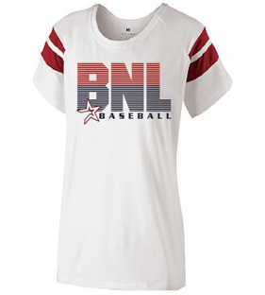 |  | 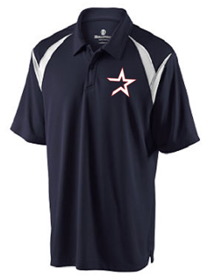 |  |  | 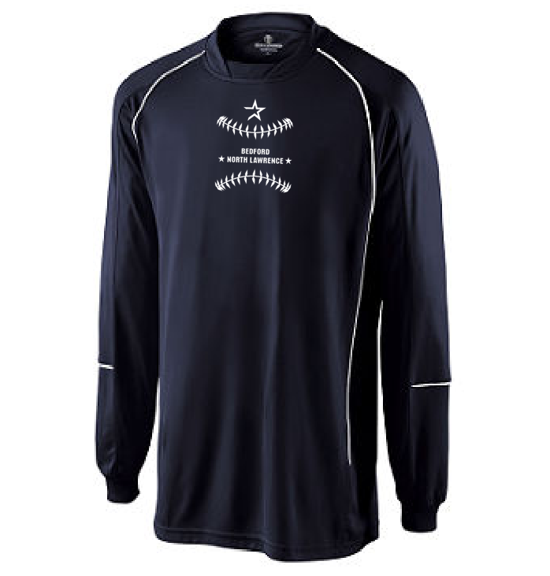
Super Soft Baby Jersey Knit |  | Soft Jersey 100% Cotton |  | Dri Excel Elite Performance |  |  | Dri- Excel Polyester Long Sleeve
Ladies Fit |  | Ladies Fit |  | Men's Polo (Embroidered Star) |  |  | Men's
22% Proceeds Returned |  | 16% Proceeds Returned |  | 11% Proceeds Returned |  |  | 11% Proceeds Returned
Garment Color: | Navy | Garment Color: | White | Garment Color: | Navy |  | Garment Color: | Navy
Print Color: | White | Print Color: | Navy/Red | Print Color: | White/Red |  | Print Color: | White
Design #: | 1 | Design #: | 2 or 2A | Design #: | 6 |  | Design #: | 1
Price (S-XL): | $17.00 | Price (S-XL): | $22.00 ($24.00 2A) | Price (S-XL): | $35.00 |  | Price (S-XL): | $35.00
Price (2XL): | $19.00 | Price (2XL): | $24.00 ($26.00 2A) | Price (2/3XL): | $37.00 |  | Price (2XL): | $37.00
#5 |  | #6 |  | #7 |  |  | #8
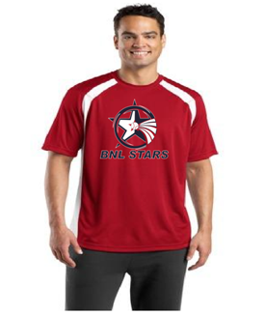 |  | 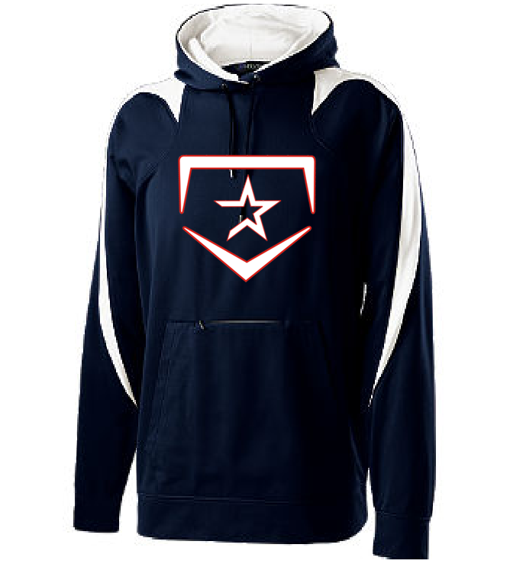 |  | 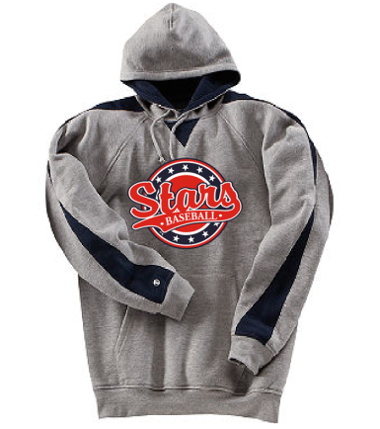 |  |  | 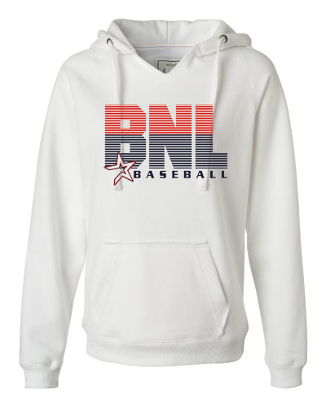
100% Polyester Loose Fit |  | Wick-Soft/Polyester Knit Hoodie |  | 80/20 Cotton/Polyester Hoodie |  |  | Split V-neck Hoodie
Men's |  | Unisex (similar to Under Armour Hoodie) |  | Unisex |  |  | Ladies
22% Proceeds Returned |  | 5% Proceeds Returned |  | 12% Proceeds Returned |  |  | 11% Proceeds Returned
Garment Color: | Red | Garment Color: | Navy/White | Garment Color: | Grey/Navy |  | Garment Color: | White
Print Color: | Navy/White | Print Color: | Red/White | Print Color: | Red/White/Navy |  | Print Color: | Red/Navy
Design #: | 5 | Design #: | 3 | Design #: | 4 |  | Design #: | 2 or 2A
Price (S-XL): | $18.00 | Price (S-XL): | $50.00 | Price (S-XL): | $40.00 |  | Price (S-XL): | $38.00 ($40.00 2A)
Price (2/3XL): | $20.00 | Price (2/3XL): | $52.00 | Price (2/3XL): | $42.00 |  | Price (2XL): | $40.00 ($42.00 2A)
#9 |  | #10 |  | #11 |  |  | #12
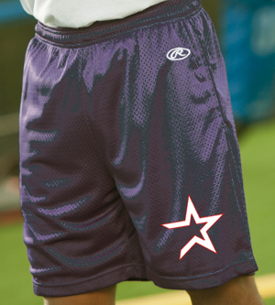 |  | 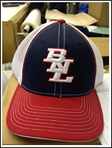 |  | 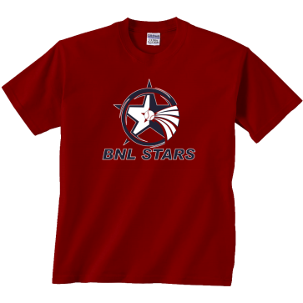 |  |  | 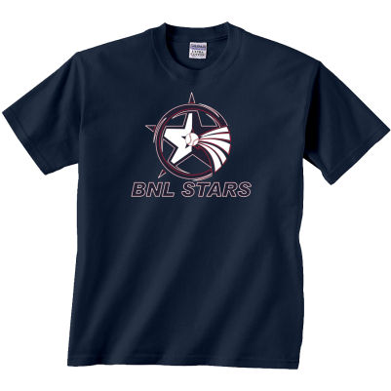
Rawlings Pocketed Gym Shorts |  | Trucker Cap Mesh Back |  | Standard T-Shirt |  |  | Standard T-Shirt
Men's |  | 3D Embroidery |  | Unisex |  |  | Unisex
30% Proceeds Returned |  | 20% Proceeds Returned |  | 30% Proceeds Returned |  |  | 30% Proceeds Returned
Garment Color: | Navy | Garment Color: | Navy/Red/White | Garment Color: |  | Red | Garment Color: |  | Navy
Design #: | 6 | Design #: | As Shown | Print Color: |  | Navy/ White | Print Color: |  | Red/White
Price (S-XL): | $16.00 | Price (S-XL): | $17.50 | Design #: |  | 1, 4, 5 | Design #: |  | 1, 4, 5
Price (2XL): | $18.00 |  |  | Price (S-XL): |  | $15.00 | Price (S-XL): |  | $15.00
 |  |  |  | Price (2/3XL): |  | $17.00 | Price (2/3XL): |  | $17.00

PRODUCT DESIGNS
#1 | #2 / #2A | #3
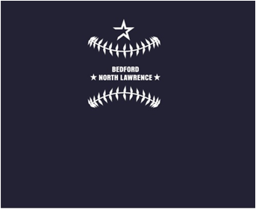 | 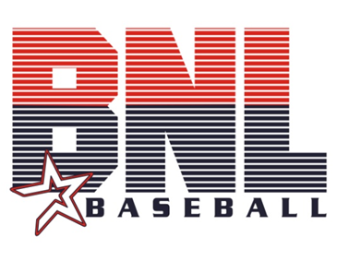 | 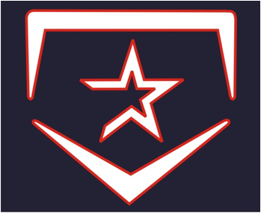
Standard Print | 2 = Standard Print | Tackle Twill with Embroidery Trim
Small Centered | 2A = Glittered Flake Print (Star Only) | Full Front
 | Full Front
#4 | #5 | #6
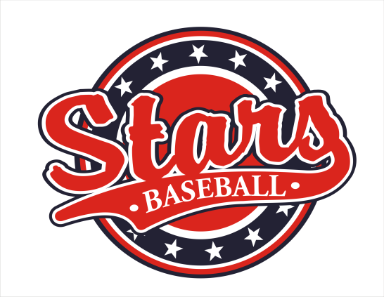 | 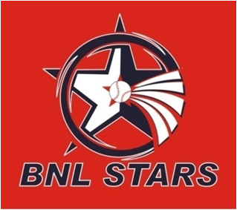 | 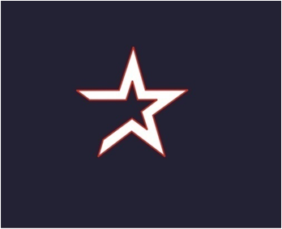
Standard Print | Standard Print | Standard Print / Embroidered (Polo)
Full Front | Full Front | Over the Heart/Short Leg

